# SQL for Data Science

## Selecting and retrieving data with SQL – Week 1

## What is SQL anyway?

It's important to understand that SQL is a non procedural language. That means you wont be able to write complete applications with it, but what you can do is interact and communicate with data.

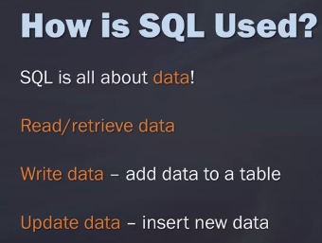

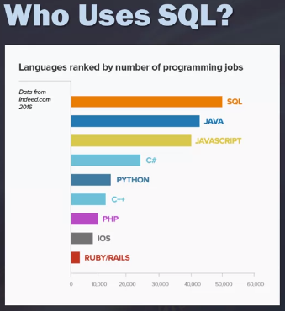

How you write some of the syntax for SQL is going to depend on the relational database management system you're interacting with. Extending our analogy you can think of this as the accent or maybe as the dialect. SQL is able to translate it for you, but sometimes you have to tweak it a little bit based on the database management system you're using.

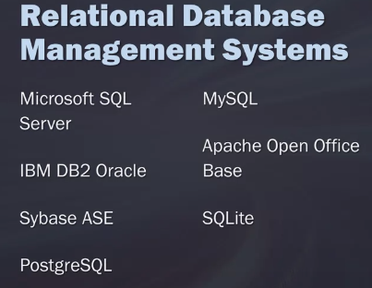

## Data Models, Part 1: Thinking About Your Data

We're going to spend some time talking about data models and Diagrams. The reason why this is important is because while you may be able to learn SQL, you won't be as effective in writing your queries without an understanding of the structure of the data that you're querying against. It wasn't until I took another class that was a bit more theory-based that I began to understand data models, Diagrams, and how those interact with SQL.

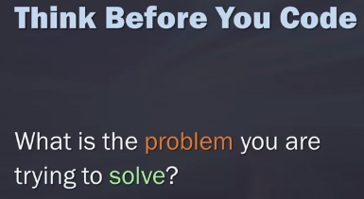

If you actually take the time to think about why you're doing what you're doing before you do it, it will actually take less time to write your queries. If you really spend some time understanding how the data relates to each other, how you're going to join this data together, what columns you need, why you need it, this will then in turn speed up the process for writing your queries.

Data modelling

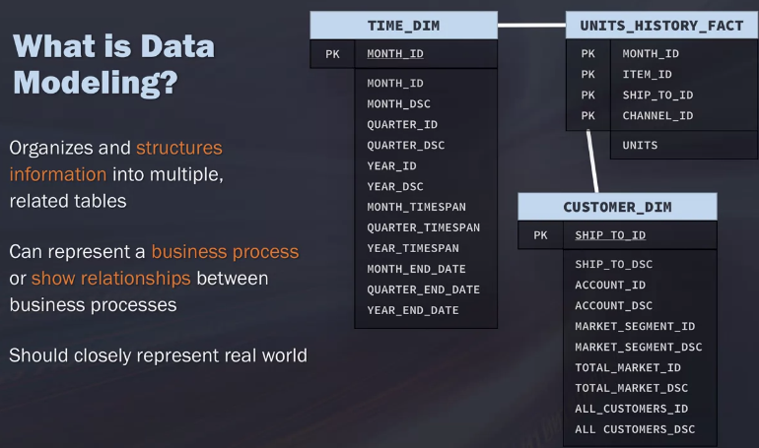

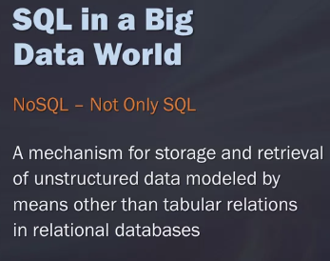

There are a few types of relationships in a database and the ones I want to cover are the three shown here: one-to-many, many-to-many and one-to-one. If you think of a one-to-many relationship, this could be one customer that has many invoices. When you think of a many-to-many relationship, this could be an example of many students to many classes. You may have one student who belongs to lots of different classes or you may have a class who has many different students.

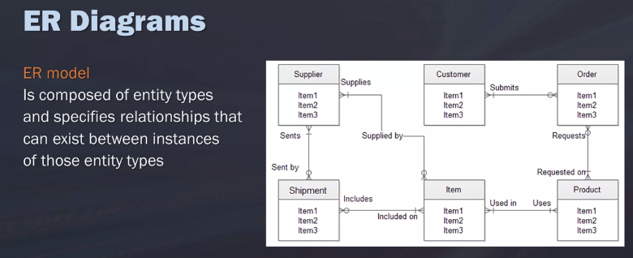

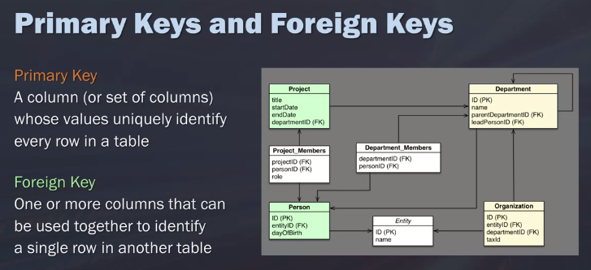

Notations of ER diagrams

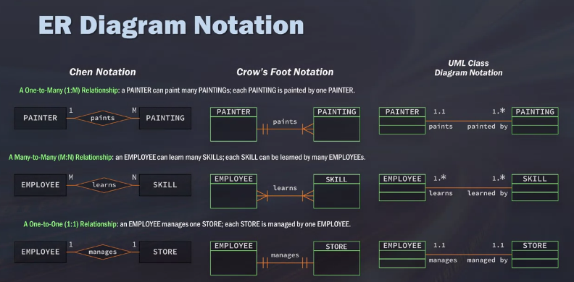

## Retrieving Data with a SELECT Statement

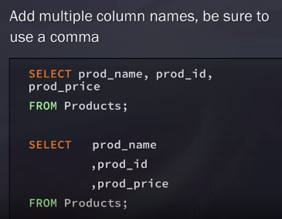

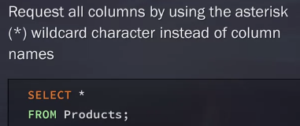

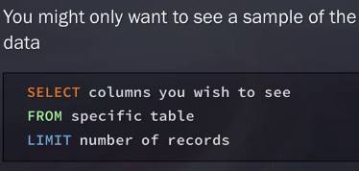

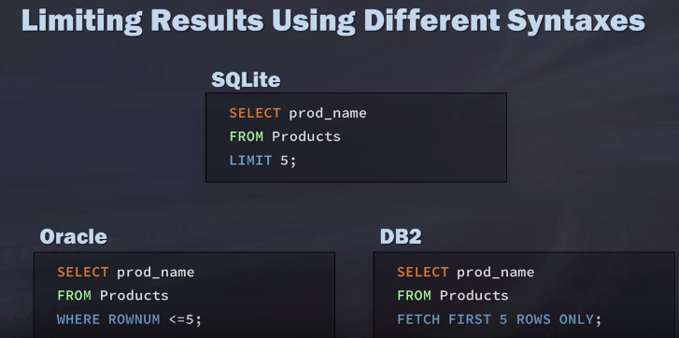

## Creating Tables

You need the name and definition of the columns. And this, you also need to define the data type.

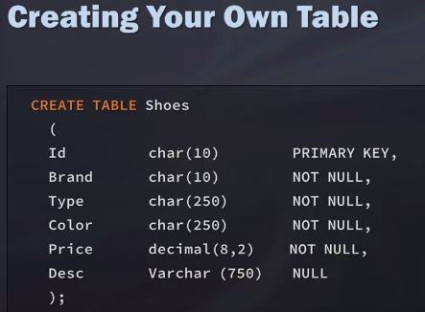

if you indicate that a column cannot be null, then you are going to get an error if you do not enter a value into that column when you're inserting data into it.

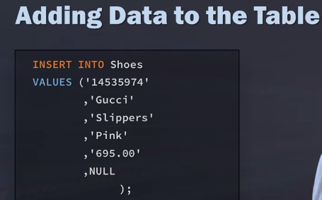

The following can be safer to can be really beneficial if you want to insert just a few values into a column. So for this example, I could remove the first three, so I could remove the Type, Brand, and Id. I would just remove those by crossing those out.

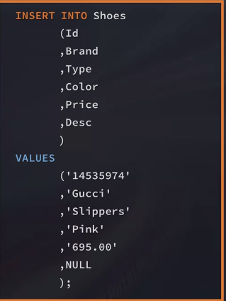

## Creating Temporary Tables

Another option we have is to create a copy, essentially of another table or pull a subset from another table. We can create a whole table from this, or we can create what is called a temporary table. First of all, the most important thing to know about these temporary tables is that these will be deleted when the current client session is terminated. These are a lot faster than real tables.

So if you have complex queries and you want to simplify it a bit by creating a subset and then joining to that subset and driving a new calculation from that, then temporary tables are a great option.

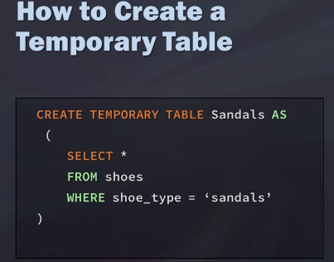

## Adding Comments to SQL

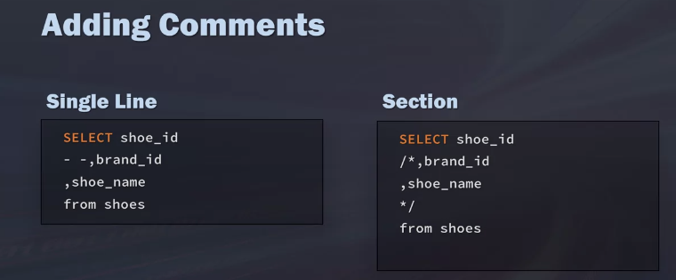

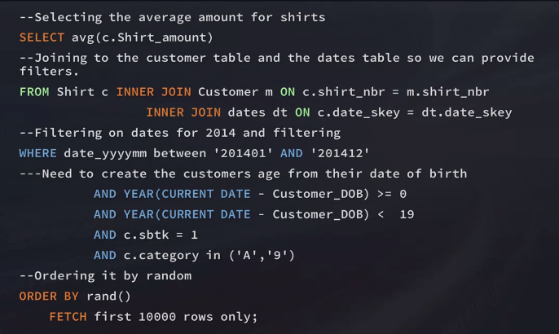

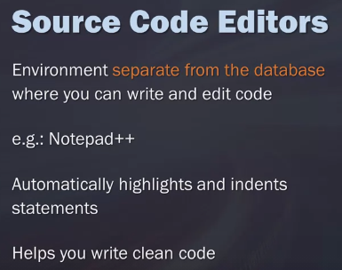

## Filtering, Sorting, and Calculating Data with SQL – Week 2

I'm going to introduce you to several methods for filtering data.

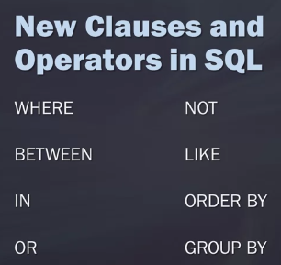

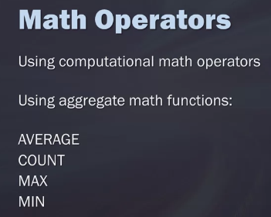

## Filtering with SQL

First of all, when we filter our data down, it will often reduce the number of records we're retrieving. Instead of just going and grabbing a whole table and pulling every column and row from it, we can get really specific about the data we want to obtain from that table. And subsequently, that reduces how much data we're pulling in from the system. Reducing the amount of data you're analyzing will, of course, speed up the query performance, which, in turn, will speed up our overall processing. It also helps when we add the filtering at the database level because this reduces the strain on the client-side of the application which will also allow it to run better.

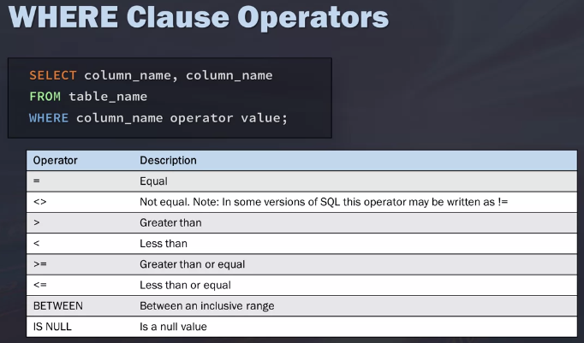

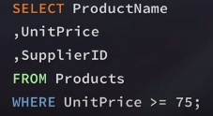

Except: we're going to look at products and their prices from different suppliers. But for this query, we don't want to include a specific product name, Alice Mutton.

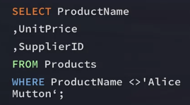

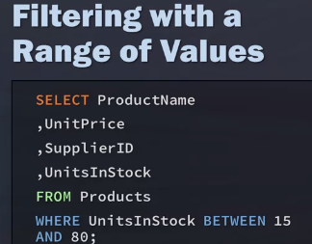

IN, OR and NOT operators

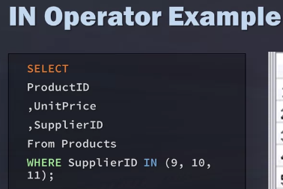

OR operator: An important thing to know about this is that a database management system will not evaluate the second condition if the first condition is met. So here we want Tofu over Konbu.

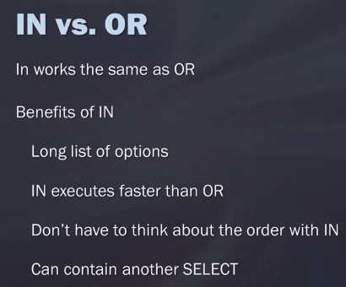

I have my SELECT statement, and I have where it's from. And I have where SupplierID equals 9 or equals 11, and I also add the unit price is greater than 15. What you'll notice though is I'm getting some unit prices that are not greater than 15. And so one of the things to understand about why this is happening is because SQL is processing the OR before the AND. And so one of the ways to limit this is to use parentheses.

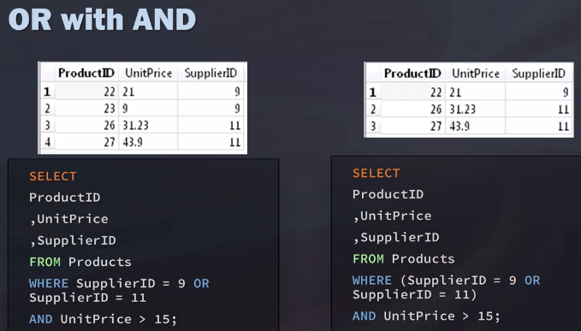

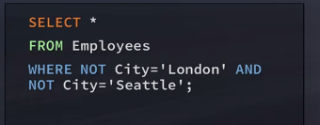

## Using Wildcards in SQL

LIKE is actually technically a predicate, not an operator. But oftentimes, it just gets referred to as an operator. So that's what we'll refer to as here.

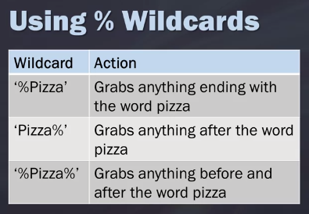

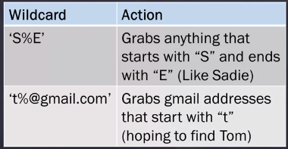

you can use wildcards with underscores. In this example, we're going to have WHERE size is LIKE, and then underscore pizza. This is going to produce an output, where it ends in the word pizza and then it brings everything before that.This isn't supported by DB2, which is a pretty popular system.

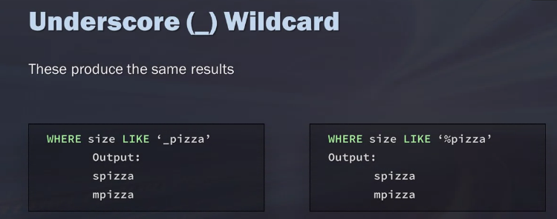

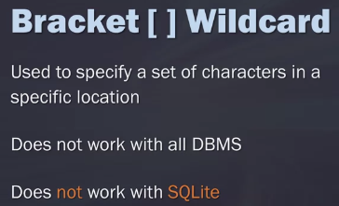

there are some downsides to using wildcards. One, queries using wildcards take a little bit longer to run. If you can use another operator such as equals, greater than, or less than to achieve your same results, you'll get a lot better performance out of your system.

## Sorting with ORDER BY

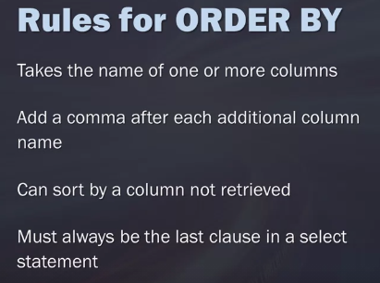

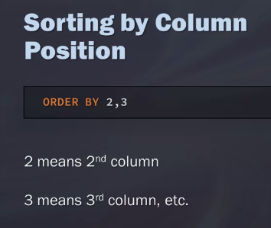

you can sort it either in ascending, A S C, or descending order, D E S C. And then, this is only applied to the column name it directly proceeds. If you're using order by descending and have unit price, it's not going to do it for all of the columns after the descending. You have to specify each individual columns for ascending and descending,

## Math Operations

we're usually working with larger amounts of data, so we really want to reduce that strain on the client application. The closer we can do this to the source, the better we'll be in the long run.

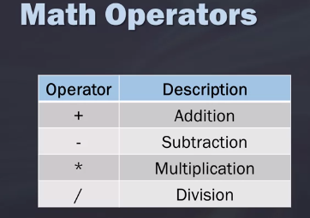

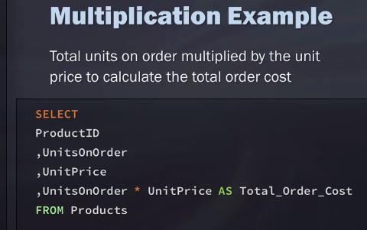

You probably remember the order of operations from math classes you've taken in the past. The idea that things in parentheses are handled first, then powers are exponents, multiplication, division, addition, and subtraction.

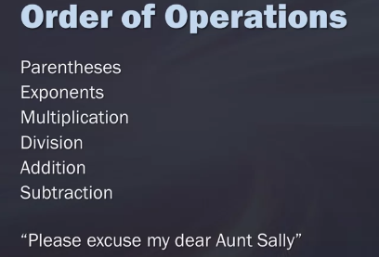

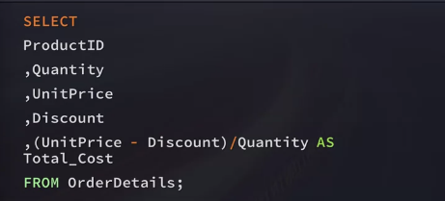

## Aggregate Functions

It's going to get even more fun in this lesson because it's time to really take a deep dive into data analysis by going over some of the aggregate functions found in SQL. Aggregate functions provide various ways to summarize your data,

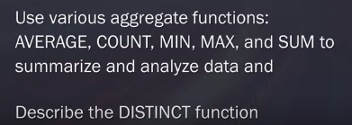

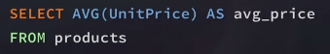

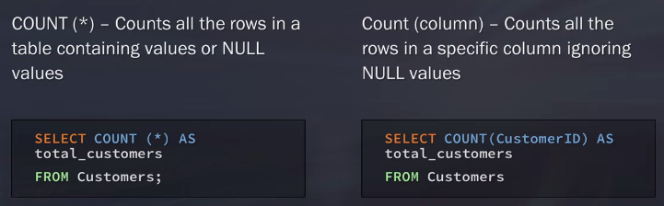

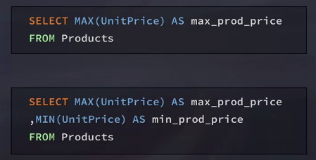

Same for sum etc.

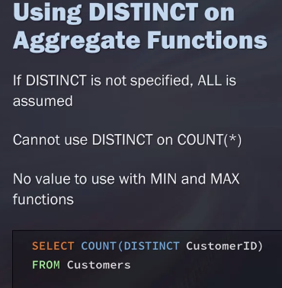

## Grouping Data with SQL

If we were to just have our select statement with select region and then we have our aggregate function count customer IDs as total customers from the customers table, we're going to get an error return. Because we haven't satisfied, okay, how do you want me to count the customer IDs? That's where we add this group by a clause. We have now after this from, we put the GROUP BY clause and what we want it to group it by.

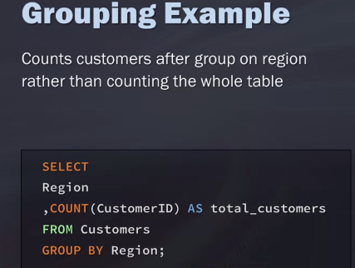

Some important things to note about the GROUP BYs is we can group it by multiple columns. We may have more columns than just region. For example, maybe we want to know region, city, country. We can list all of those in our GROUP BY clause. We will just add a comma after every column that we want listed. One of the things to note that's really important is all of the fields that your pulling in with the aggregate function need to be on your GROUP BY clause, except for the aggregated calculation. Null will be grouped as its own.

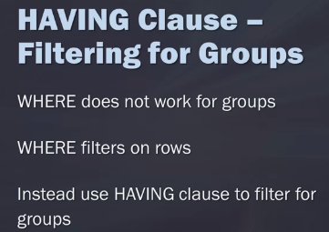

In the following example, we want the count of orders for customers. But we only want to see the total orders for the customers who've had more than two orders. So to do this, we're going to select our customer IDs, then we're going to count all of the records as orders.We're going to get this from our orders table. And then since we want to look at this by each individual customer, we're going to group it by our customer ID. Then to be able to make sure we're only selecting those customers who had orders greater than or equal to 2, we'll place our HAVING clause of HAVING COUNT greater than or equal to 2. Again, just remember that WHERE filters before the data is grouped and then HAVING filters after the data is grouped.

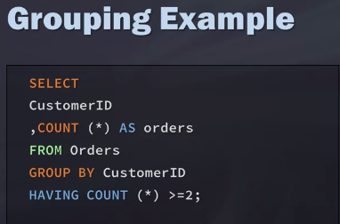

## Subqueries and Joins in SQL – Week 3

There are a lot of times as a data scientist where you'll need to combine or merge data from two or more places in order to help you with your analysis.

## Using Subqueries

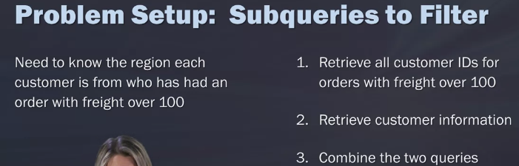

How we're using this query is to filter for customers, that we're getting back. My filtering criteria in this example is to find records where the freight is over 100. I'm first going to take that first query I wrote, which is to select the customer IDs from orders where freight is over 100. And that's going to be my main base. I'm going to filter down to that and then I'm going to go and expand and add to it. This is your innermost query.

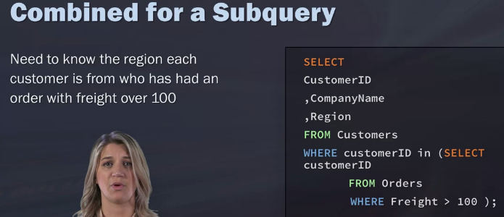

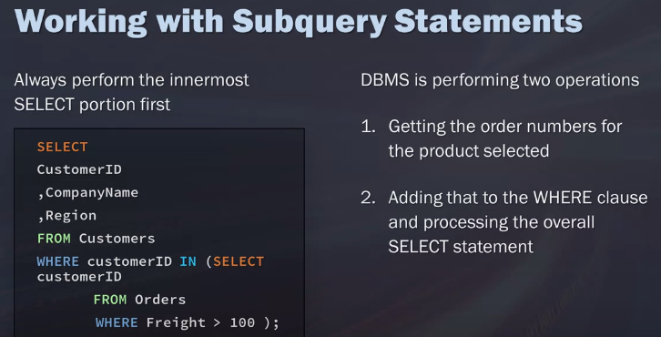

## Subquery Best Practices and Considerations

One thing to note is that subquery selects can only retrieve a single column. You can't say, hey, go select all these columns from this table and then bring them in my overall query. It's only going to select a single column at a time.

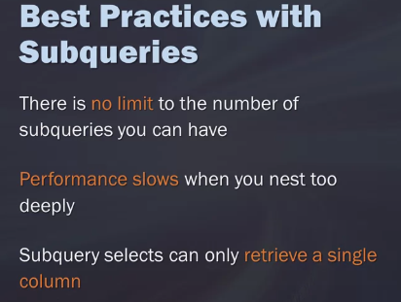

Make sure you properly indent

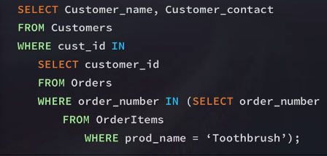

Use [www.poorsql.com](http://www.poorsql.com) to format query.

A unique use of sub query in select. In this example, you can see it just treats it like another additional column. But really helpful when you're wanting to do some calculations and do a calculated fill on another table.

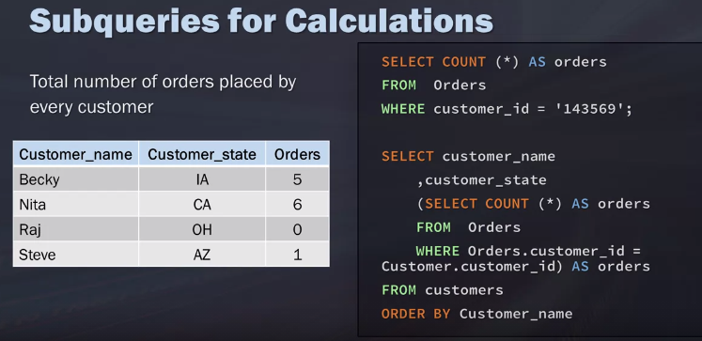

## Joining Tables: An Introduction

you can combine information from multiple tables primarily by using subqueries. As we learned though, due to some limitations, subqueries aren't always the best way to combine information.

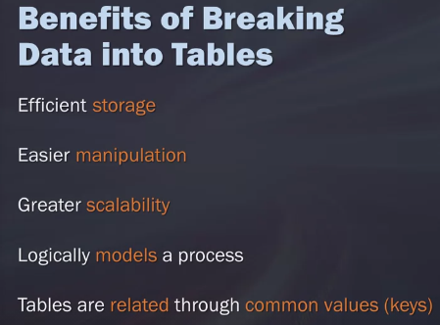

## Cartesian (Cross) Joins

So to begin, with a Cartesian join, this allows you to take each record from the first table and match it with all of the records from the second table. So a way to think of this is the first table contains x rows, and the second table connects y rows. You'll have the end result of X times Y.

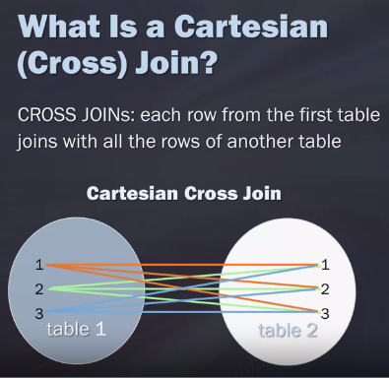

So we'll have our select, the columns that we want, and this will be going over the product name, the unit price that's from the product's table, and then the company name from the supplier's table. So you'll notice, I just listed out the columns that I wanted, even though they are from two separate tables. And then I'm going to list from suppliers where it's coming from. But it's also coming from products, so I'll list out from products as well. But in between that, I want to state the type of join I want to do.

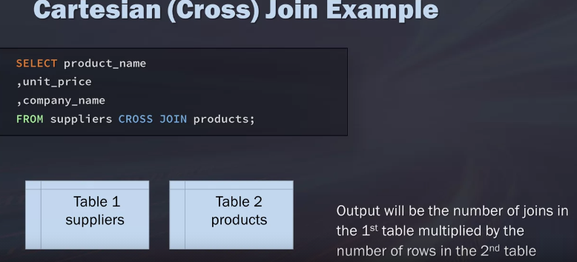

from suppliers and then cross joined with products. So this, because we are just saying hey times every record in the first table by the number in the second table, we don't need any key or qualification, right? we had 29 records in 1 table and 77 in the other table. And then our end result is 2,233 records.

## Inner Joins

So this is where keys become really important in tables.

So if company name is something that was listed both in products and suppliers, it wouldn't know which table to pull it from. So I would prequalify it by listing out suppliers before the company name like this, so that I would know for sure where to pull it from.

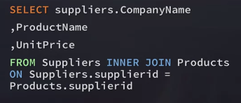

Joins are expensive.

Here though, because I have multiple tables, it's really important that I'm prequalifying my names. So if you look in my from statement, I have orders and then I just list o. So I'm prequalifying the orders table as being o. I do this just because it's a little bit quicker to write out. You could just prequalify orders as orders. Some other people list out their tables where they say orders would be a, customers would be b, employees would be c.

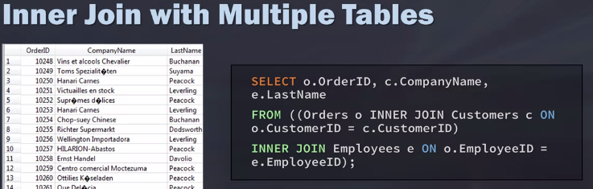

## Aliases and Self Joins

We've used aliases when we are aggregating the field, so if we're taking the average selling price we'll oftentimes create an alias for that so we know what to call the name. We can do a similar thing when we're using tables and joining tables together. And why we do this is because it makes it a lot easier to read and write.

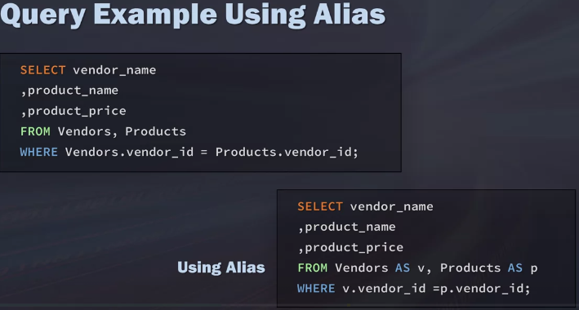

We can actually join a table to itself. And perhaps, not surprisingly, these are called self joins. In this instance, what we're going to do is we're going to match customers that are from the same city.

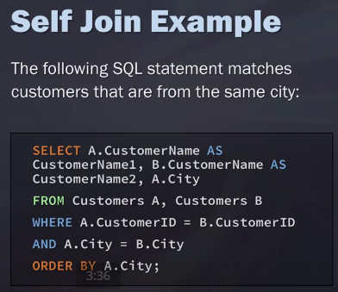

## Advanced Joins: Left, Right, and Full Outer Joins

Left join you still want everything from the customer table. I don't care if they didn't have an order but if they did, and then bring it also all together and bring it in in one order table.

So that's the left join. The right join is very similar except in this instance, if we still stick with customers tables is on the left and orders is on the right. What this would do is pull in all the orders whether or not a customer is associated with that order or not.

Full outer joins, just return and give me everything whether there's matching one or matching two.

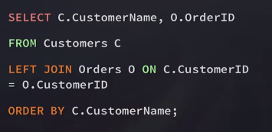

## Unions

The union is one of those things that I wouldn't say I use a lot in my day to day work. But when I do need it, I'm like yes, this is exactly the thing I need to use to get the job done.

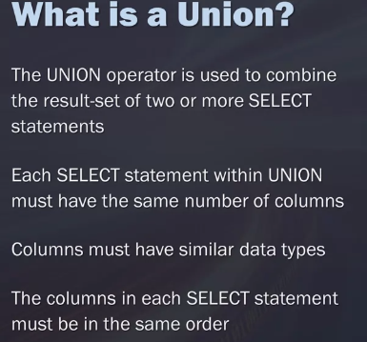

a UNION is used to combine the results of two or more queries or table sets into one table and one statement. So each select statement gets unioned with each other and kind of stacked on top of each other. The best way I can think of this is when I may ask someone to build me a building that's 20 stories tall and I have 2 people to build it. So I may ask the first person to build the the first ten floors, and the second person to build the top ten floors. So that's great, both of them can work independently from each other. But at the same point, I want to put these two back together.

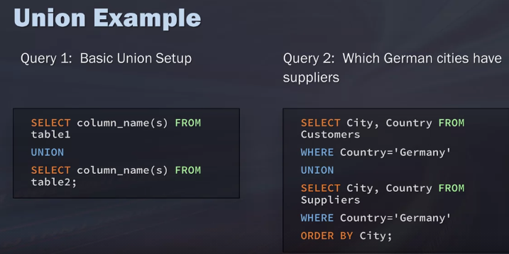

we're going to write two separate queries, one to get what cities from the customers and then the cities from the suppliers. And then we going to add those together, so we know where we have a presence, whether it's by a customer or by a supplier.

## Best practices

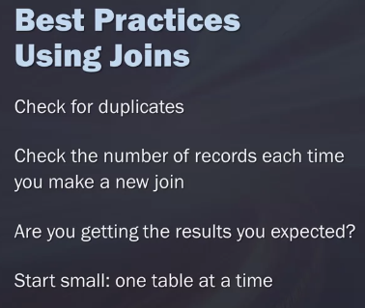

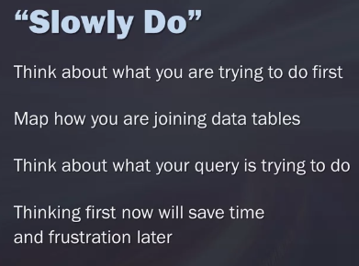

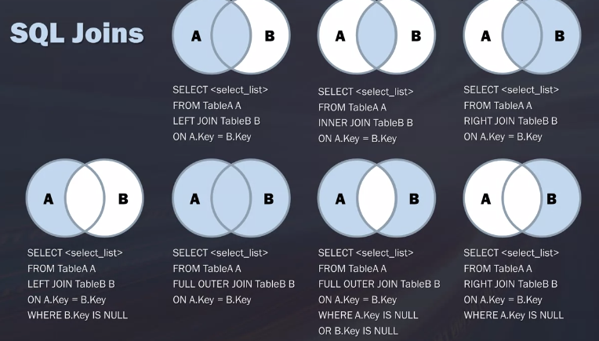

## SQL for Data Science – Week 4

## Working with Text Strings

Data scientists often have to integrate and harmonize data from a variety of sources, and the data that you're integrating, is it always formatted in the same way? This can obviously cause problems when you're trying to blend this data together.

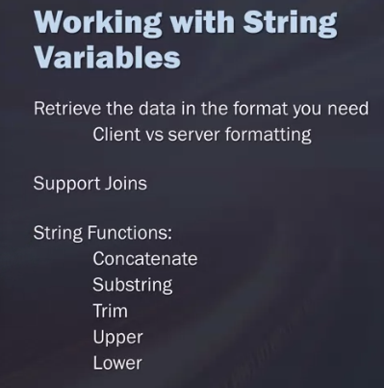

you want to concatenate the first couple letters of a person's first name and the first couple letters of the last name, or maybe you just want a unique category or field. To do this, we're going to do is use the pipe or vertical bar key.

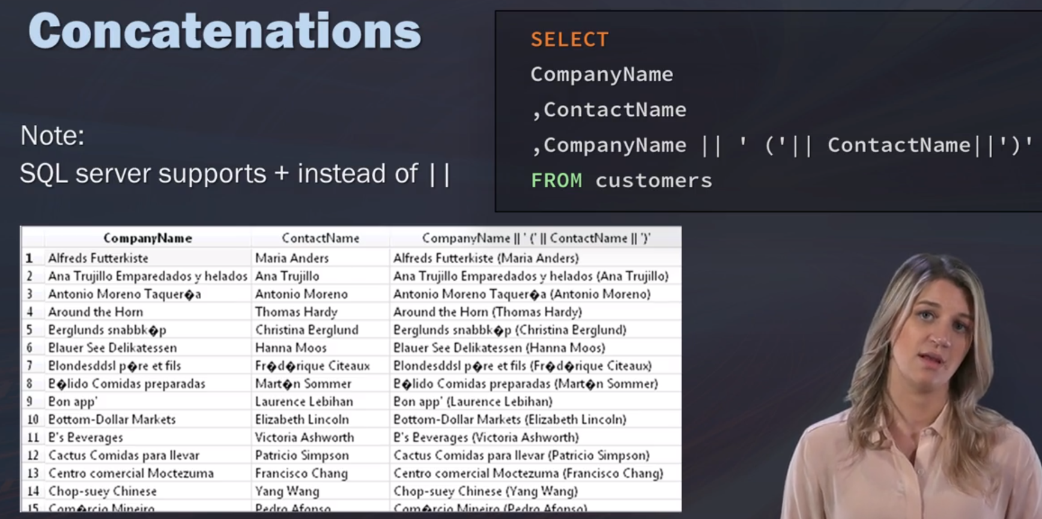

Here, you can see my string is the thing that says, 'you the best' and there's trailing spaces before and after that. When I put it in parentheses and I have called the trim function before it, we can see that the end result takes care of all of the trailing spaces.

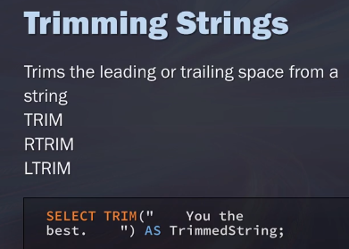

Substring

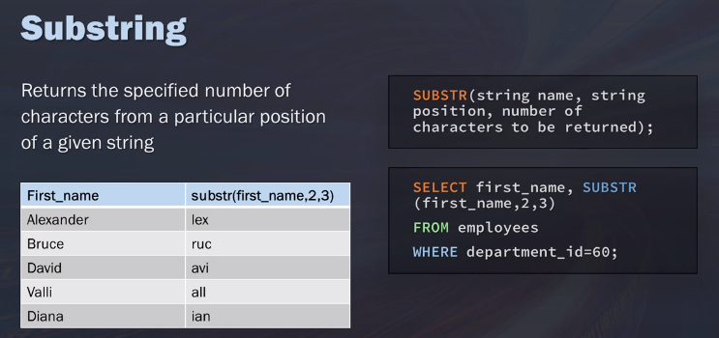

Upper and lower cases. UCASE is the same as UPPER.

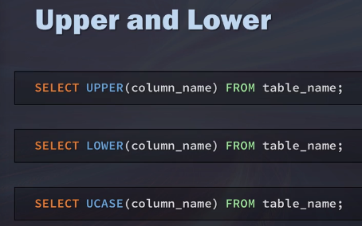

## Working with Date and Time Strings

you aren't going to get any results back and this is because it's in this format that also has the hours, minutes, and seconds. Sometimes you need to convert it, because maybe for your analysis, you don't maybe care about the level of detail.

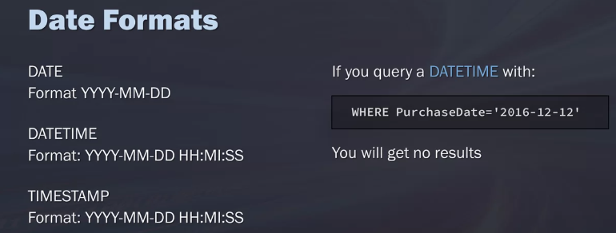

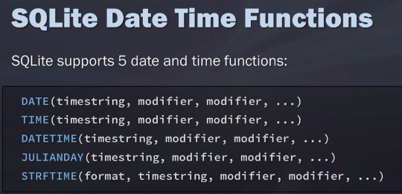

Use the STRFTIME for date and time.

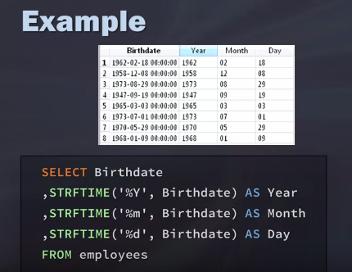

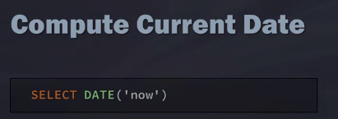

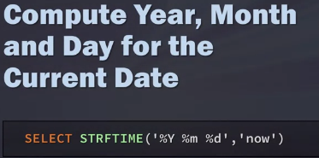

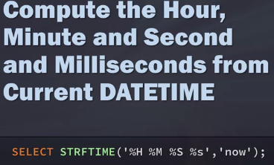

Calculating age

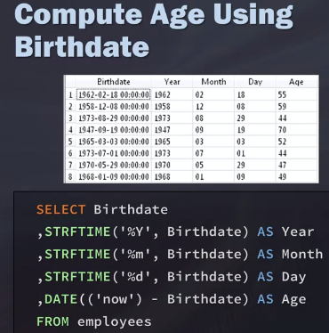

## Case Statements

The case statement is a built-in function that mimics an if-then-else kind of statement found in most programming languages. This can be used in select, insert, update, and delete statements. The logic that the case statement takes is as follows. You're going to say, case, and then, when, and then you'll have a condition. Then after you say the condition, you put, then, and what the result expression will be. So you could have multiple cases when it's a certain expression and what you want the result to be, and that could go on for a while.

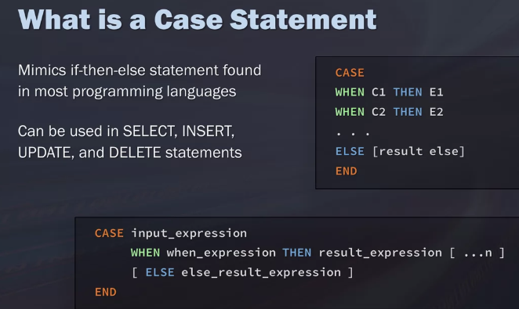

To do this, I'm going to say, CASE City, and then, WHEN it's Calgary, and I have that in my quotation because it's a string, then I'm going to classify it as Calgary. Also, I'll classify it as Other, then I'm going to end this, and I'm going to call the calculation, Calgary.

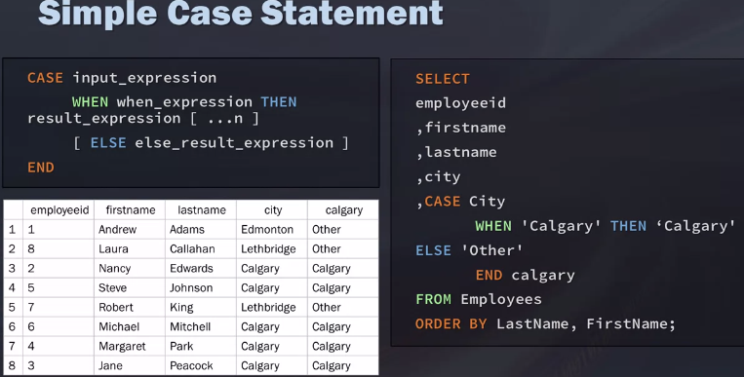

A second way of doing case - Using case to bin values – search case statement

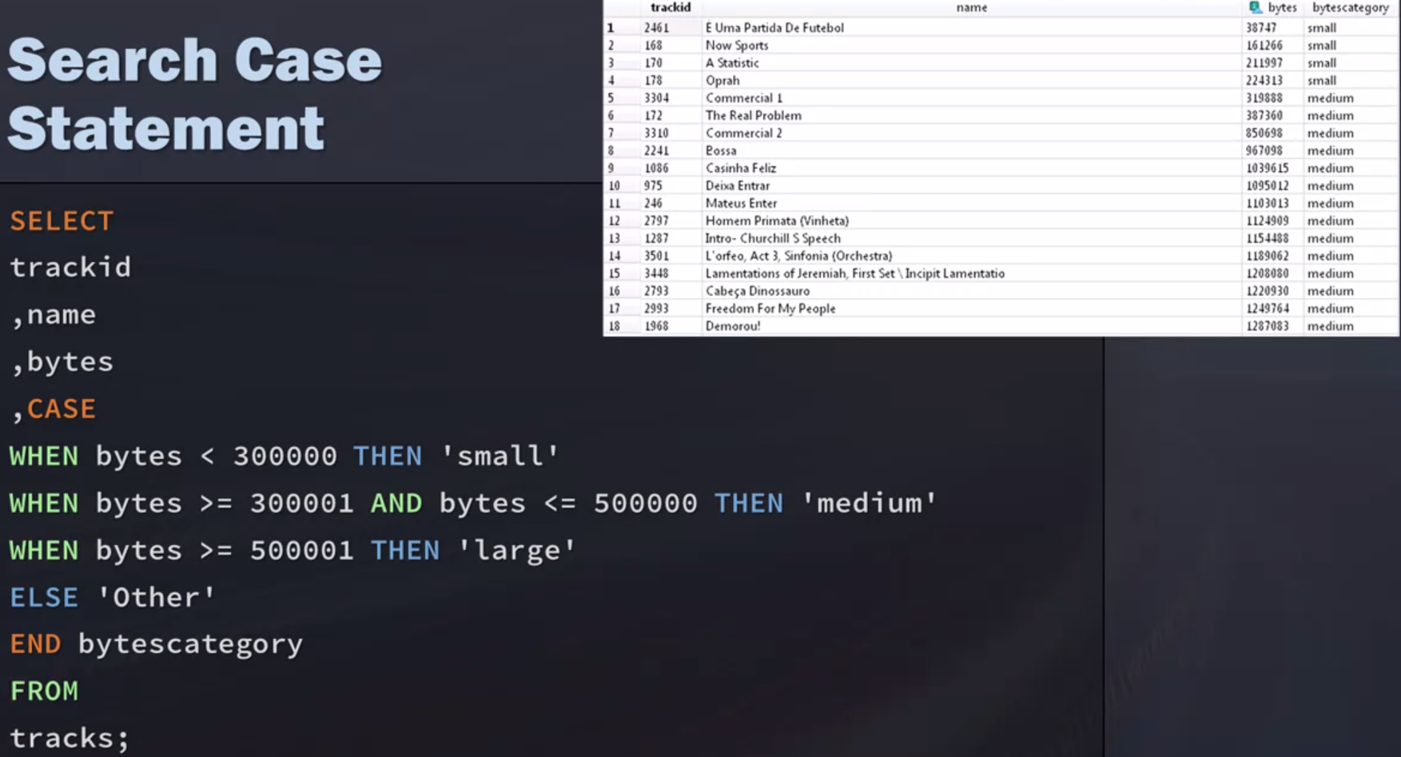

## Views

Instead of creating a whole new table, sometimes we can create the illusion of a table by using a view. A view is essentially a stored query, and it helps us clean up our queries and simplify when we have to write.

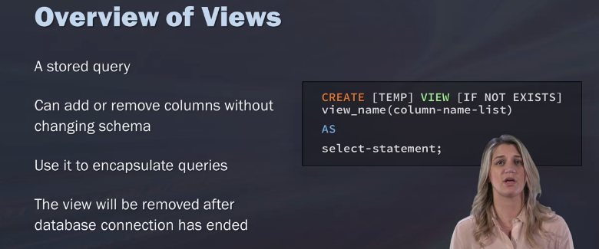

Let's say I want to get a count of how many territories each employee has. If you look at our Diagram, this information is separated out from each other. I'm going to create a view, so that on that view, I can just run a simple count on the number of territories. So here I will create my view. Then for my view, I'm just going to call it as my_view. Then, the AS is really the select statement. Remember how before we've used AS as an alias to say what we want our column name to be? You can think of a view as a whole table, but now you're saying what do you want in all of that table? Your AS is going to be a select statement for what I want in that view.

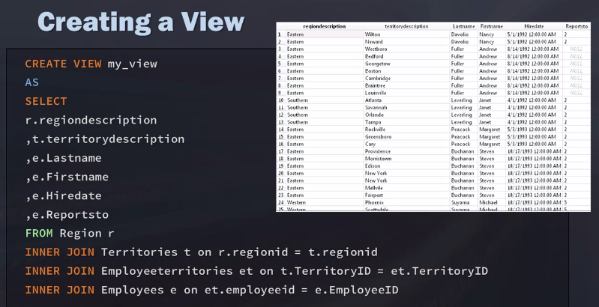

If we did not need this view, we can use



The beauty of the view is that it can be used like a table. But it's unlike a table in that you don't have to have ETL or run ETL on any of the data.

## Data Governance and Profiling

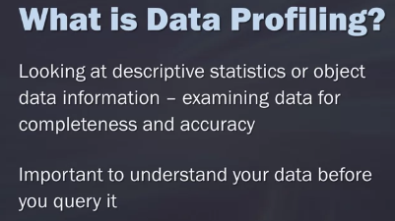

Some of the things you can do as part of profiling is start with just understanding how many rows are in the table. You can also look at when was the object last updated? Meaning when did the data get refreshed and reloaded? Because this may change some of your results. This may change the data that you need to limit it by.

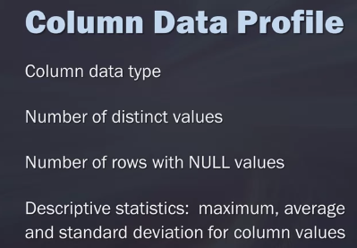 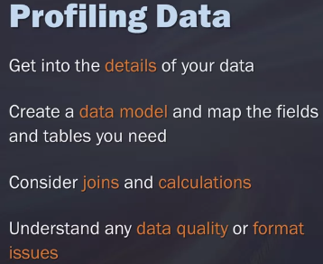

In terms of governance, this is really dependent upon what the data strategy is at the company you're working for. Some have really strict governance policies, and some are more open and free. In terms of a data site using SQL, it's important to understand what your read and write capabilities are in the different environments. Is there a sandbox you can play in and work in to do some of the transformations and things like that to your data? These are good questions to ask. But understanding the governance around the data and what you're actually able to do is important to know to keep your environments clean.



Then also understand what the promotional process is through your environments. If you created a model and you want to give those predictive scores and write them back to the database, what environments do you have set up? Is this something that you're gonna be able to go through development, acceptance, and production? What is the process for that and what are you writing it to?

## Using SQL for Data Science

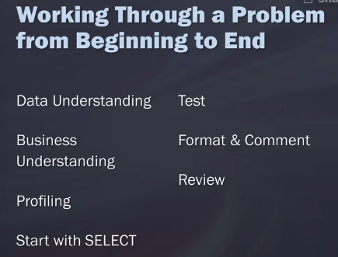

All of this starts with the data understanding. This is the most important step. This is why we spent so much time understanding and explaining modeling and Diagrams, and discussing the relationships in your data. Because understanding your data is key to being able to write successful queries. What I mean by understanding your data is really kind of a combination of data understanding and business understanding.

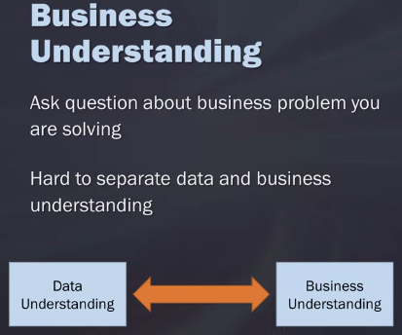

For example, “we want to predict whether or not a customer is likely to buy our product”. That seems pretty straight forward and easy, right? But as you dive into the data more, you may start to get questions like, well, what customers? What products? Some of the things that are unspoken are certain logical exclusions. For example, are there certain customers that should be excluded from the this analysis? Are there certain cases where past cells shouldn't be added into this model, or should it be counted? This is why you have to walk in between that data understanding and business understanding.

## Six Examples Using MySQL Window Functions

Window functions are an advanced SQL feature available in most popular databases. MySQL had not supported them for a long time, but that changed in Version 8.0. They are helpful not only for analysts and people who create reports, but also for other professionals who use databases to select data needed. In this article, we explain the syntax of some popular window functions with practical examples.

## What is window function

Window functions operate on a window frame, or a set of rows that are somehow related to the current row. They are similar to GROUP BY, because they compute aggregate values for a group of rows. However, unlike GROUP BY, they do not collapse rows; instead, they keep the details of individual rows.

A very useful feature especially for data analysts, marketers, and financial specialists, most popular relational databases support window functions today. MySQL had not supported them until it finally caught up starting in Version 8.0, when they were added as a new advanced feature.

For people who have worked exclusively in MySQL, window functions may be something completely new. If you’re a MySQL specialist who has been using it since before Version 8.0, learn this new feature! Find out why you should in the article [“Why Should I Learn SQL Window Functions?”](https://learnsql.com/blog/why-should-i-learn-sql-window-functions/).

How do window functions work? Consider the table **sale** shown below, with columns product ID (ID), price (value), and year of sale (sale_year). Suppose we want to add the column prev_value for each product, containing the value of the previous year. See the picture below, which shows how the window function LAG() works:

The query looks like this:

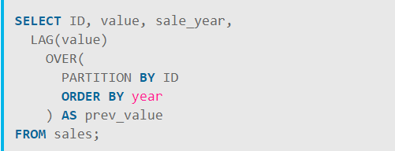

The query divides the result set into partitions: one for ID 1 and the other for ID 2. Within each partition, the sale value from the previous year is obtained. Note that the year 2016 for ID 2 is the first row of the partition and therefore has no previous row within the partition; consequently, the prev_value column is NULL. For the same ID, the year 2017 is the second row in the partition; the prev_value is 80.00, which is the value from the year 2016.

As you can see, we specify an OVER clause after naming the window function. Within this clause, we use PARTITION BY to define the partitions and ORDER BY to define the sorting within each partition. Other window functions work much in the same way.

Some window functions are ranking functions like RANK(), DENSE_RANK(), and ROW_NUMBER(), while others are analytic functions like LAG() and LEAD().

Ranking functions return a rank value for each row within each partition; in contrast, analytic functions point to preceding or subsequent rows within each partition. If no partitions are defined, all rows are treated as one big partition.

Let’s look at some examples!

### Example 1: The RANK() Function

The RANK() function is used mainly to create reports. It computes the rank for each row in the result set in the order specified.

The ranks are sequential numbers starting from 1. When there are ties (i.e., multiple rows with the same value in the column used to order), these rows are assigned the same rank. In this case, the rank of the next row will have skipped some numbers according to the quantity of the tied rows. For this reason, the values returned by RANK() are not necessarily consecutive numbers.

Let’s see an example. Consider the following table, **product**:

| id | name | category | ranking_score |
| --- | --- | --- | --- |
| 1 | Sofa Alan | living room | 3422 |
| 2 | Desk Mirian | office | 1777 |
| 3 | Sofa Frank | living room | 1777 |
| 4 | Armchair Ivo | living room | 1201 |
| 5 | Cabinet AWE | office | 4547 |
| 6 | Armchair Alex | living room | 1201 |

The query below displays the columns name, category, and ranking_score. It also ranks the rows using the RANK() function in the order defined by the column ranking_score:

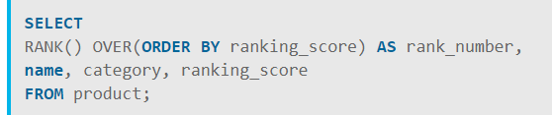

Here is the result of the query:

| rank_number | name | category | ranking_score |
| --- | --- | --- | --- |
| **1** | Armchair Ivo | living room | 1201 |
| **1** | Armchair Alex | living room | 1201 |
| **3** | Desk Mirian | office | 1777 |
| **3** | Sofa Frank | living room | 1777 |
| 5 | Sofa Alan | living room | 3422 |
| 6 | Cabinet AWE | office | 4547 |

After the RANK(), we have an OVER() clause with an ORDER BY. The ORDER BY is mandatory for ranking functions. Here, the rows are sorted in ascending order according to the column ranking_score. The order is ascending by default; you may use ASC at the end of the ORDER BY clause to clarify the ascending order, but it is not necessary.

The first two products, Armchair Ivo and Armchair Alex, both have ranking_score equal to 1201, so they are tied at rank number 1. The rank for the next value of ranking_score, 1777, is 3 and not 2, because there are 2 rows with the rank 1. The ranks start at 1, but the next rank has skipped according to the repeated ranks of the previous rows.

### Example 2: The DENSE_RANK() Function

DENSE_RANK() is similar to RANK(), but it does not allow gaps in ranks in the way RANK() does. Let’s see an example.

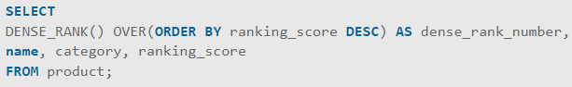

This query displays the same columns as in the previous example, but with dense_rank_number defined by DENSE_RANK() instead of rank_number defined by RANK(). The rows are still sorted by the column ranking_score, but this time in descending order denoted by DESC at the end of the ORDER BY clause.

The Desk Mirian and Sofa Frank have the same ranking_score (1777) and are assigned a dense_rank_number of 3. DENSE_RANK() returns 4 next and doesn't account for the repeated ranks as does the RANK() function. The article [“Overview of Ranking Functions in SQL”](https://learnsql.com/blog/sql-rank-function-vs-row-number-vs-dense-rank/) explains the difference between these functions.

The result of this query looks like this:

| dense_rank_numbe r | name | category | ranking_score |
| --- | --- | --- | --- |
| 1 | Cabinet AWE | office | 4547 |
| 2 | Sofa Alan | living room | 3422 |
| **3** | Desk Mirian | office | 1777 |
| **3** | Sofa Frank | living room | 1777 |
| **4** | Armchair Ivo | living room | 1201 |
| **4** | Armchair Alex | living room | 1201 |

### Example 3: The ROW_NUMBER() Function

Another popular ranking function used in databases is ROW_NUMBER(). It simply assigns consecutive numbers to each row in a specified order. Let’s see an example:

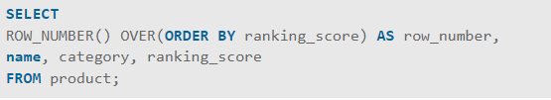

The query first orders the rows by ranking_score in ascending order. It then assigns row numbers consecutively starting with 1. The rows with ties in ranking_score are assigned different row numbers, effectively ignoring the ties.

The result of this query looks like this:

| row_number | name | category | ranking_score |
| --- | --- | --- | --- |
| 1 | Armchair Ivo | living room | 1201 |
| 2 | Armchair Alex | living room | 1201 |
| 3 | Desk Mirian | office | 1777 |
| 4 | Sofa Frank | living room | 1777 |
| 5 | Sofa Alan | living room | 3422 |
| 6 | Cabinet AWE | office | 4547 |

### Ranking Within Each Partition

You can assign ranks separately within each partition with RANK(), DENSE_RANK(), or ROW_NUMBER(). This is done by dividing rows into partitions by a column or a combination of columns then assigning ranks independently within each partition.

Here is an example:

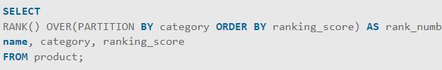

This query defines ranks separately within each category. For the category “living room,” the rank starts at 1 and ends at 4; in the “office” category, the rank starts at 1 and ends at 2.

Here is the result of this query:

| rank_number | name | category | ranking_score |
| --- | --- | --- | --- |
| 1 | Armchair Ivo | living room | 1201 |
| 1 | Armchair Alex | living room | 1201 |
| 3 | Sofa Frank | living room | 1777 |
| 4 | Sofa Alan | living room | 3422 |
| 1 | Desk Mirian | office | 1777 |
| 2 | Cabinet AWE | office | 4547 |

The rank numbering is defined separately for each category, since each category is a partition (PARTITION BY category). The records are sorted by ranking_score (ORDER BY ranking_score) within each partition (category), and the ranks are calculated within each partition.

### Example 4: The LEAD() Function

Analytical functions are a different type of window functions. They are used to compute a value within a group of rows, returning some value from a preceding row or from a subsequent row within the row group. Analytical functions are useful for finding differences in a particular column between a given row and some preceding or subsequent row. For example, you can compare the difference of a particular column between the current row and the adjacent row.

The first analytic function we will examine is LEAD(). In its simplest form, LEAD() takes the value of a given column stored in the next row.

Consider the table below, **toys_sale**:

| id | toy_name | month | sale_value |
| --- | --- | --- | --- |
| 1 | robot | 3 | 23455 |
| 2 | robot | 4 | 12345 |
| 3 | robot | 5 | 23000 |
| 4 | kite | 3 | 6890 |
| 5 | kite | 4 | 7600 |
| 6 | kite | 5 | 9120 |
| 7 | ball | 3 | 45123 |
| 8 | ball | 4 | 42000 |
| 9 | ball | 5 | 20300 |
| 10 | puzzle | 5 | 67000 |

and the following query:

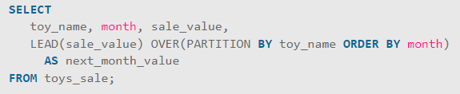

The LEAD() function returns the value of sale_value in the next row. We have partitions in this example—the name of the toy—so only the rows within the same partition are considered. In contrast to ranking functions, LEAD() takes an argument—the name of the column whose value it will return from the next row.

Here is the result of the query:

| toy_name | month | sale_value | next_month_value |
| --- | --- | --- | --- |
| ball | 3 | 45123 | 42000 |
| ball | 4 | 42000 | 20300 |
| ball | 5 | 20300 | **NULL** |
| kite | 3 | 6890 | 7600 |
| kite | 4 | 7600 | 9120 |
| kite | 5 | 9120 | **NULL** |
| puzzle | 5 | 67000 | **NULL** |
| robot | 3 | 23455 | 12345 |
| robot | 4 | 12345 | 23000 |
| robot | 5 | 23000 | **NULL** |

For the last row in the partition, the next value is always NULL. Look at Month 5 for all of the toys. This is because Month 5 is the last month in the partition. There is no month that follows Month 5 in the partition, and the next sale_value does not exist.

### Example 5: The LAG() Function

LAG() is similar to LEAD(). Both LEAD() and LAG() can be used to compute the difference between a given row and another row. The difference is that LAG() returns the value from a preceding row, whereas LEAD() returns the value from a subsequent row.

Take a look at the following query:

|  |
| --- |
| SELECT toy_name, month, sale_value,    LAG(sale_value) OVER(PARTITION BY toy_name ORDER BY month) AS prev_month_value,    LAG(sale_value) OVER(PARTITION BY toy_name ORDER BY month)- sale_value as difference  FROM toys_sale; |

Each toy name is a partition. Within each partition, the query returns the sale value from the previous month and stores it in the column prev_month_value. For Month 5, prev_month_value contains the sale value from Month 4. It is NULL for Month 3, because there is no previous month within the partition.

In addition, this query calculates the difference in sale values between the current month and the previous month and stores the difference in the column difference. Here is the result:

| toy_name | month | sale_value | prev_month_value | difference |
| --- | --- | --- | --- | --- |
| ball | 3 | 45123 | **NULL** | **NULL** |
| ball | 4 | 42000 | 45123 | 3123 |
| ball | 5 | 20300 | 42000 | 21700 |
| kite | 3 | 6890 | **NULL** | **NULL** |
| kite | 4 | 7600 | 6890 | -710 |
| kite | 5 | 9120 | 7600 | -1520 |
| puzzle | 5 | 67000 | **NULL** | **NULL** |
| robot | 3 | 23455 | **NULL** | **NULL** |
| robot | 4 | 12345 | 23455 | 11110 |
| robot | 5 | 23000 | 12345 | -10655 |

### Example 6: The Running Total

You can also calculate running totals in MySQL using the SUM() function. The article [“What Is a SQL Running Total and How Do You Compute It?”](https://learnsql.com/blog/what-is-a-running-total-and-how-to-compute-it-in-sql/) describes the running total in detail.

Take a look at this query:

|  |
| --- |
| SELECT toy_name, month, sale_value,  SUM(sale_value) OVER(PARTITION BY toy_name ORDER BY month) AS total_toy_value  FROM toys_sale; |

It calculates the cumulative sum of the sale values for each toy and saves it into a new column, total_toy_sale. For Month 3, it is simply the sale value of that month, because it is the first row in the partition. However, for Month 4, it is the sum of sale values from Months 3 and 4; for Month 5, it is the sum of sale values from Months 3, 4, and 5. This calculation is called the running total, because the sum is updated with each successive row.

| toy_name | month | sale_value | total_toy_value |
| --- | --- | --- | --- |
| ball | 3 | 45123 | 45123 |
| ball | 4 | 42000 | 87123 |
| ball | 5 | 20300 | 107423 |
| kite | 3 | 6890 | 6890 |
| kite | 4 | 7600 | 14490 |
| kite | 5 | 9120 | 23610 |
| puzzle | 5 | 67000 | 67000 |
| robot | 3 | 23455 | 23455 |
| robot | 4 | 12345 | 35800 |
| robot | 5 | 23000 | 58800 |